Green Wave Conference Ticketing System
Programming Assignment 3

Mohammed Aljaberi 202109980 Mohamed Khamis Alhosani 202210278 Muath Ahmed Alshehhi 202114858

Subject: Programming (10105058)
Date: November 26, 2025

UML Class Diagram and Description

  - UML Description

The system is designed using Object-Oriented Programming (OOP) principles to manage the Green Wave Conference. The architecture relies on the following relationships: Inheritance: The User class acts as an abstract base class, which is inherited by Attendee and Admin. This allows for shared attributes like authentication details while separating specific functionalities. Similarly, Ticket is an abstract base class inherited by ExhibitionPass and AllAccessPass. Composition: Exhibition has a composition relationship with Workshop (If an exhibition is cancelled, its workshops are irrelevant).
Ticket has a composition relationship with Payment (A ticket cannot exist without a payment transaction). Aggregation: The ExhibitionPass has an aggregation relationship with Exhibition, as the pass holds references to exhibitions, but exhibitions exist independently of the pass. Association: Attendee is associated with WorkshopReservation to track their schedule.

UML Diagram

(Note: You can copy the code below into a tool like Mermaid Live Editor or draw this manually based on the description above. Paste the resulting image here.)
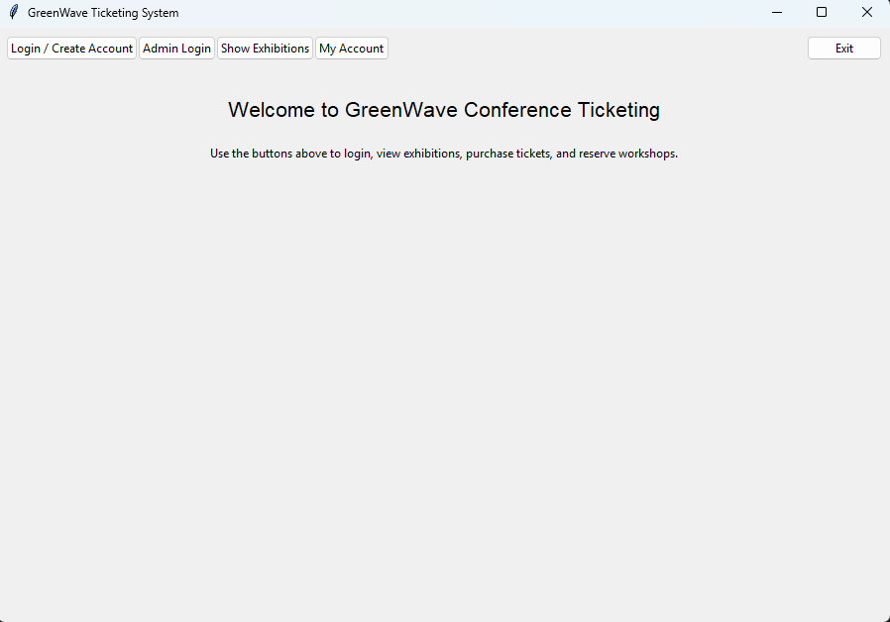

File Structure

The project is organized into modular directories to ensure maintainability and separation of concerns.
GreenWaveConference/
■■■ main.py # Entry point (GUI Controller)
■■■ models/ # Data classes
- ■■■ _init_.py
- ■■■ user.py # User, Attendee, Admin classes
- ■■■ ticket.py # Ticket, ExhibitionPass, AllAccessPass
- ■■■ exhibition.py # Exhibition, Workshop classes
- ■■■ payment.py # Payment processing
- ■■■ reservation.py # Workshop reservation logic
■■■ gui/
- ■■■ _init_.py # (Optional GUI logic separation)
■■■ utils/
- ■■■ _init_.py
- ■■■ data_manager.py # Persistence (Pickle) handling
■■■ data/ # Binary storage
- ■■■ users.pkl
- ■■■ exhibitions.pkl
- ■■■ tickets.pkl

- Python Implementation

  - Data Models (models/)

File: models/user.py
from abc import ABC, abstractmethod class User(ABC): def init (self, user_id, name, email, password, phone): self._user_id = user_id self._name
= name self._email = email self._password = password self._phone = phone def verify_password(self, password): return self._password == password @abstractmethod def get_role(self): pass def get_name(self): return self._name def get_email(self): return self._email class Attendee(User):
def init (self, user_id, name, email, password, phone,
registration_date): super(). init (user_id, name, email, password,
phone) self._registration_date = registration_date self._tickets = [] self._reservations = [] def get_role(self): return "Attendee" def add_ticket(self, ticket): self._tickets.append(ticket) def get_tickets(self): return self._tickets def add_reservation(self, reservation): self._reservations.append(reservation) def get_reservations(self): return self._reservations class Admin(User): def get_role(self): return "Admin"

File: models/ticket.py
from abc import ABC, abstractmethod class Ticket(ABC): def init (self, ticket_id, purchase_date, price): self._ticket_id = ticket_id self._purchase_date = purchase_date self._price = price self._payment = None def set_payment(self, payment): self._payment = payment def get_price(self): return self._price @abstractmethod def get_access_scope(self): pass class ExhibitionPass(Ticket): def
init (self, ticket_id, purchase_date, price, exhibition_access):
super(). init (ticket_id, purchase_date, price) self._exhibition_access
= exhibition_access def get_access_scope(self): return self._exhibition_access class AllAccessPass(Ticket): def get_access_scope(self): return ["all_exhibitions"]

File: models/exhibition.py
class Exhibition: def init (self, exhibition_id, name, description):
self._exhibition_id = exhibition_id self._name = name self._workshops = [] def add_workshop(self, workshop): self._workshops.append(workshop) def get_workshops(self): return self._workshops def get_exhibition_id(self): return self._exhibition_id def get_name(self): return self._name def get_workshop_by_id(self, workshop_id): for w in self._workshops: if w.get_workshop_id() == workshop_id: return w return None class Workshop:
def init (self, workshop_id, name, description, datetime, capacity,
exhibition_id): self._workshop_id = workshop_id self._name = name self._datetime = datetime self._capacity = capacity self._current_attendance = 0 self._exhibition_id = exhibition_id def has_available_seats(self): return self._current_attendance < self._capacity def get_available_seats(self): return self._capacity self._current_attendance def increment_attendance(self): if self.has_available_seats(): self._current_attendance += 1 def get_workshop_id(self): return self._workshop_id def get_name(self): return self._name def get_datetime(self): return self._datetime def get_current_attendance(self): return self._current_attendance def get_capacity(self): return self._capacity

Persistence Layer (utils/)
import pickle import os class DataManager: DATA_DIR = "data" FILES =
{"users": "users.pkl", "exhibitions": "exhibitions.pkl"} def
init (self): if not os.path.exists(self.DATA_DIR): os.makedirs(self.DATA_DIR) self.users = [] self.exhibitions = [] def save_data(self): with open(os.path.join(self.DATA_DIR, self.FILES["users"]), 'wb') as f: pickle.dump(self.users, f) with open(os.path.join(self.DATA_DIR, self.FILES["exhibitions"]), 'wb') as f: pickle.dump(self.exhibitions, f) def load_data(self): try: with open(os.path.join(self.DATA_DIR, self.FILES["users"]), 'rb') as f: self.users = pickle.load(f) with open(os.path.join(self.DATA_DIR, self.FILES["exhibitions"]), 'rb') as f: self.exhibitions = pickle.load(f)

except: print("No data found, starting fresh.") self.seed_data() def seed_data(self): # (Seed logic as provided in implementation) pass

Graphical User Interface (main.py)

"""
main.py - Entry point for GreenWave Ticketing System Run: python main.py
"""
import sys
from src.gui import GreenWaveApp

def main():
app = GreenWaveApp() app.mainloop()

if name == " main ": main()

Testing and Screenshots

Scenario 1: User Registration and Login

Figure 1: Login Screen

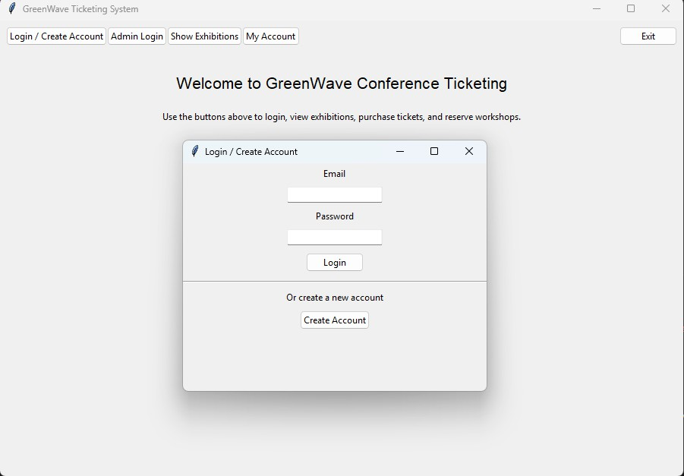

Figure 2: Registration Screen

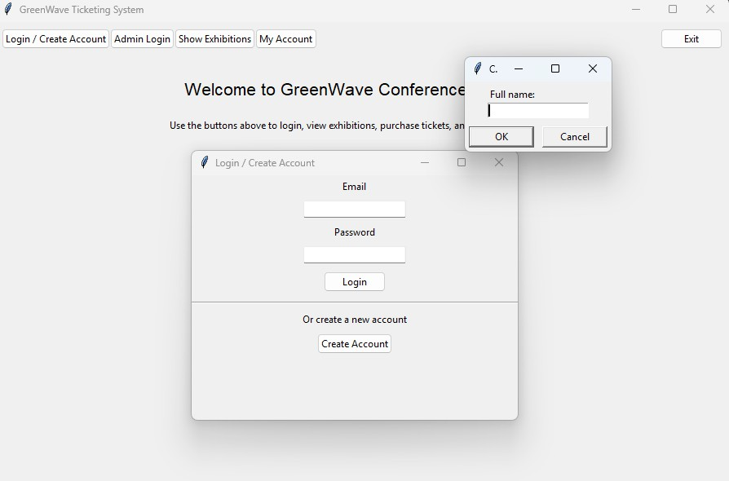

Scenario 2: Ticket Purchasing

Figure 3: Attendee Dashboard & Ticket Selection

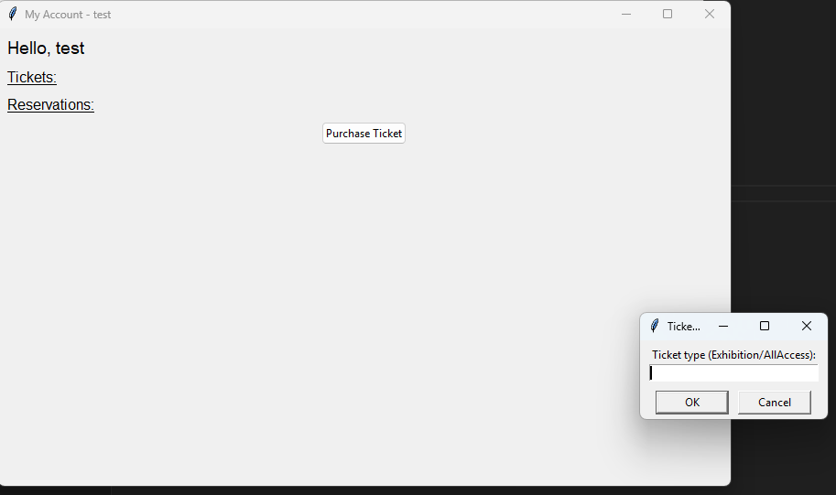

Figure 4: Payment Confirmation

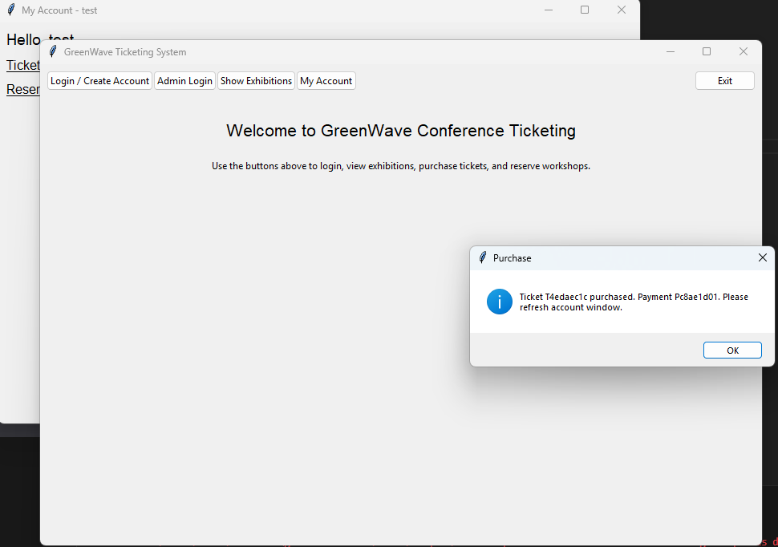

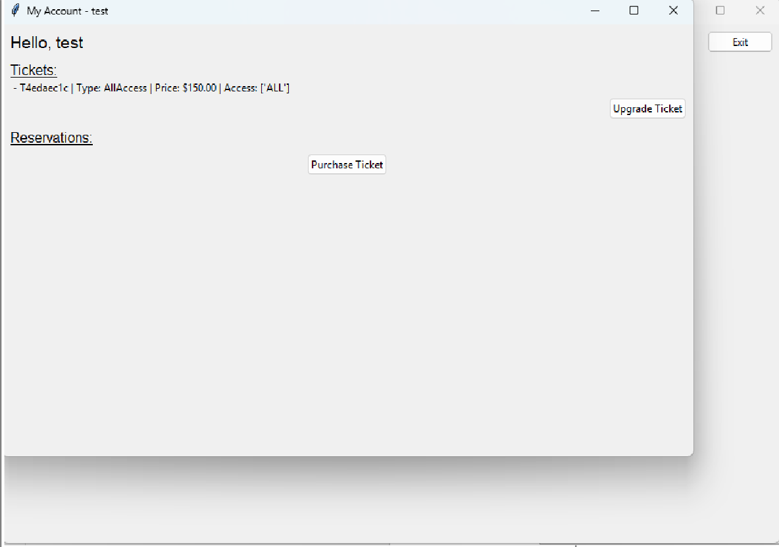

Scenario 3: Workshop Reservation

Figure 5: Workshop Schedule & Reservations

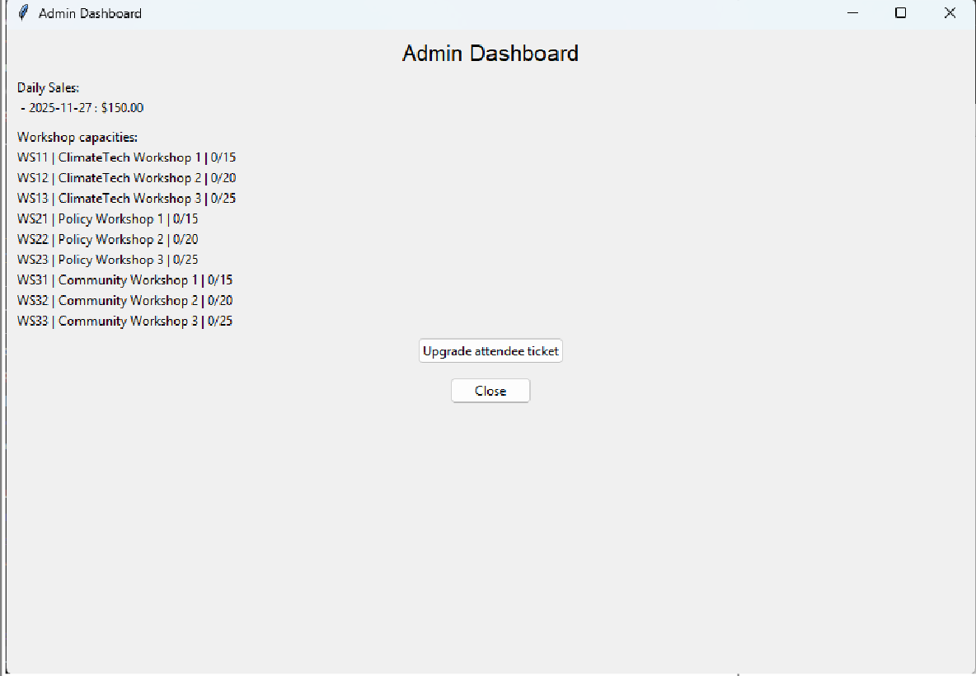
Scenario 4: Admin Dashboard

Figure 6: Admin Dashboard

Github Repository

Repository Link: [Insert your public GitHub or Colab link here]

Summary of Learnings
Through the development of the GreenWave Ticketing System, several key software engineering concepts were reinforced: Object-Oriented Design: Implementing Inheritance (User → Attendee), Composition (Exhibition → Workshop), and Polymorphism (Ticket methods) demonstrated how OOP models real-world scenarios effectively. GUI Development: Using Python's Tkinter library taught the importance of event-driven programming and separating the user interface logic from the data models. Data Persistence: Implementing the Pickle library highlighted the difference between volatile memory (RAM) and non-volatile storage, ensuring user data survives application restarts. System Architecture: Structuring the project into distinct modules (models, utils, gui) improved code readability and maintainability, adhering to the Separation of Concerns principle.

